PROJECT TITLE
AI-Based Project Risk Prediction System using Machine Learning with Full-Stack and DevOps Integration

A course project report submitted in partial fulfilment of the requirement
of
DEVOPS AND FULLSTACK
by

G. Bharath Kumar (2303A52082)

Under the guidance of
Dr. N.VENKATESH
Asst. Professor, Department of CS & AI


SR University, Warangal
APRIL-2026
ABSTRACT:
This project presents the design and implementation of an AI-Based Project Risk Prediction System using machine learning, full-stack development, and DevOps practices. The primary objective of the system is to analyze software project data and predict potential risks such as project delays, budget overruns, and failure probability.
The system integrates real-time data analysis and predictive modeling to evaluate key project parameters including project duration, team size, task completion rate, and repository activity. GitHub API integration is used to extract live project metrics such as commits, contributors, and issue activity, enabling dynamic and data-driven risk assessment.
Secure user authentication is implemented using JWT and bcrypt, with MongoDB used for storing user data and project records. The frontend provides an interactive dashboard for visualizing risk levels, trends, and insights using charts and AI-generated summaries.
DevOps practices such as version control, continuous integration, and deployment are applied to ensure scalability, reliability, and efficient development workflows. The system eliminates dependency on static analysis and provides a real-time, intelligent risk monitoring solution.
This project demonstrates how machine learning, full-stack development, and DevOps can be combined to build a scalable and production-ready risk prediction system.

CONTENTS

ABSTRACT ii

Chapter No. Title Page No.

1 INTRODUCTION 01
1.1 About the project 01
1.2 Objectives 02

2 LITERATURE REVIEW
2.1 Overview 03
2.2 Related Studies and Existing Solutions 05
2.3 Tools and Technologies Used 07

3. METHODOLOGY
3.1 System Design and Architecture 08
3.2 Implementation Details 10
3.3 Application Workflow 12

4 RESULTS AND DISCUSSION
4.1 System Output and Features 14
4.2 Performance Analysis 16
4.3 Discussion 18

5 CONCLUSION AND FUTURE WORK
5.1 Summary of Findings 19
5.2 Conclusions Drawn 20
5.3 Future Scope 20

CHAPTER 1: INTRODUCTION
1.1 About the Project:
The AI-Based Project Risk Prediction System is designed to analyze software projects and predict potential risks such as delays, failures, and inefficiencies. The system uses data-driven analysis and real-time metrics to evaluate project health and provide early warnings.
The application allows users to input project details or analyze GitHub repositories to extract key indicators such as commit activity, issue count, contributor involvement, and update frequency. These factors are processed using a structured risk scoring model to classify projects into Low, Medium, or High risk categories.
The system replaces traditional manual risk assessment methods with an automated and intelligent approach that helps project managers take proactive decisions.

1.2 Objectives:
- To develop an intelligent system for predicting project risks
- To analyze real-time project data using GitHub API
- To classify projects into Low, Medium, and High risk levels
- To provide actionable insights and recommendations
- To build a secure full-stack application
- To integrate DevOps practices for deployment

CHAPTER 2: LITERATURE REVIEW

2.1 Overview:
Project risk prediction is a critical aspect of software project management. Traditional methods rely on manual analysis, which is often inaccurate and time-consuming. Modern systems use data-driven techniques to analyze project performance and predict risks efficiently.
This project leverages real-time data and analytical models to evaluate project health and provide insights for better decision-making.

2.2 Related Studies and Existing Solutions:
Existing tools like Jira and Trello focus on project tracking but do not provide predictive risk analysis. Research in machine learning shows that project risks can be identified using patterns in historical and real-time data.
Many systems lack integration with real-time repositories and fail to provide actionable insights. This project improves upon existing solutions by combining GitHub data with a structured risk prediction model.
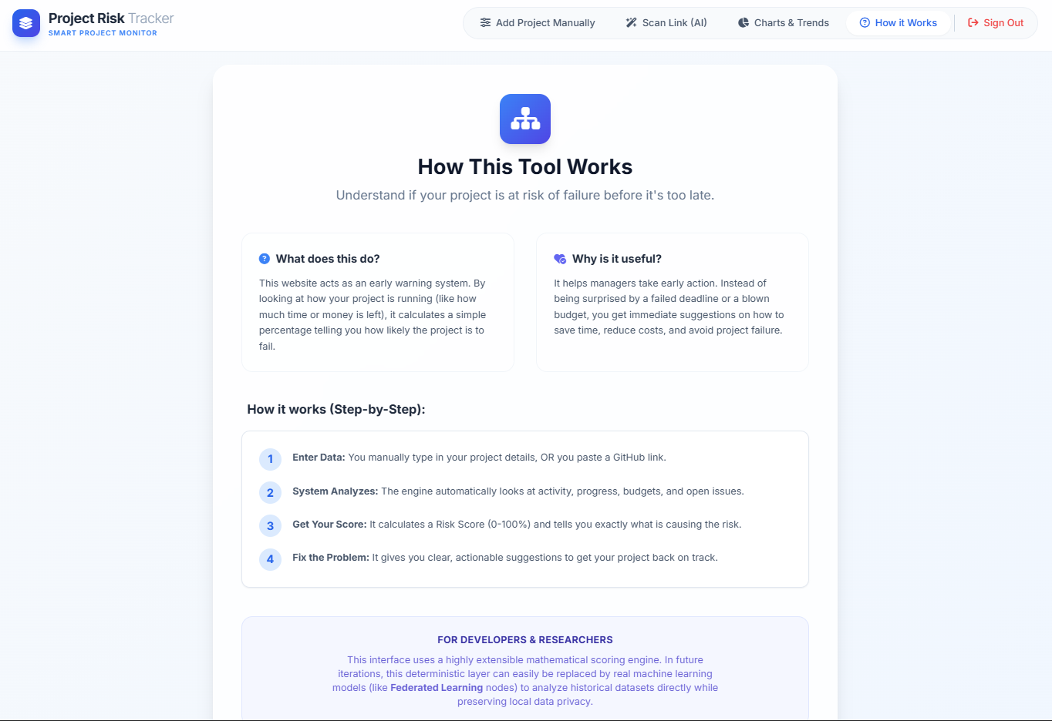
2.3 Tools and Technologies Used:
- Frontend: HTML, Tailwind CSS, JavaScript
- Backend: Node.js, Express.js
- Database: MongoDB Atlas
- Authentication: JWT, bcrypt
- API: GitHub REST API
- Visualization: Chart.js
- DevOps: Git, GitHub, CI/CD



CHAPTER 3: METHODOLOGY

3.1 System Design and Architecture:
The system follows a client-server architecture.
- Frontend handles user interaction
- Backend processes data and risk analysis
- MongoDB stores user and project data
- GitHub API provides real-time project metrics
Workflow:
Frontend → Backend → GitHub API → Risk Analysis → Database → Frontend

3.2 Implementation Details:
The system is implemented using a full-stack approach.
- Authentication using JWT and bcrypt
- GitHub API integration for fetching repository data
- Feature extraction (commits, issues, contributors)
- Risk scoring using weighted factors
- Visualization using charts and dashboards

3.3 Application Workflow:
- User logs in or registers
- User enters project details or GitHub URL
- System fetches project data
- Risk analysis is performed
- Risk score is generated
- Results are displayed
- Data is stored in MongoDB

CHAPTER 4: RESULTS AND DISCUSSION

4.1 System Output and Features:
The system provides:
- Risk score (0–100%)
- Risk level (Low / Medium / High)
- Visual charts and trends
- AI-generated insights
- User dashboard

4.2 Performance Analysis:

The system performs efficiently for real-time data analysis. API calls and data processing are optimized using asynchronous methods.The accuracy of predictions depends on input data quality and selected features.

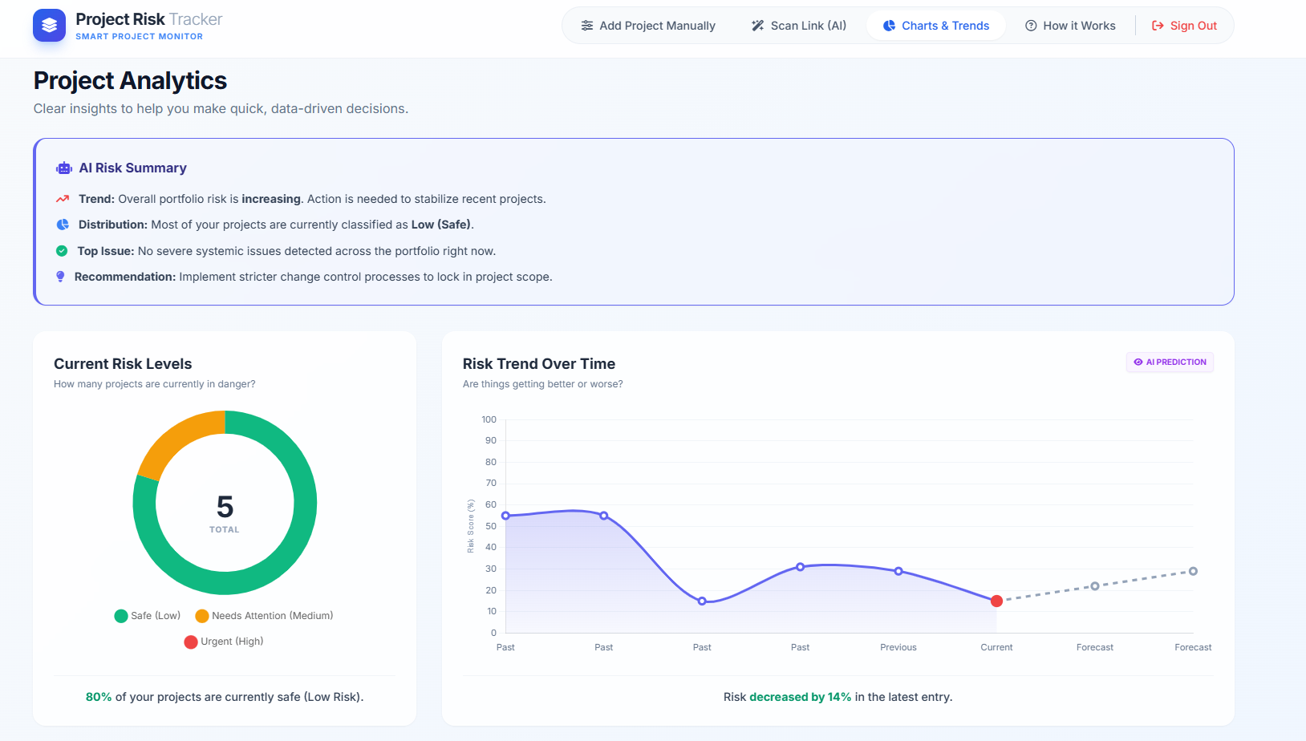

4.3 Discussion:
The system demonstrates how automated analysis can improve project risk prediction. It reduces manual effort and provides quick insightsHowever, the current system uses rule-based logic. Future improvements can include machine learning models for better accuracy.
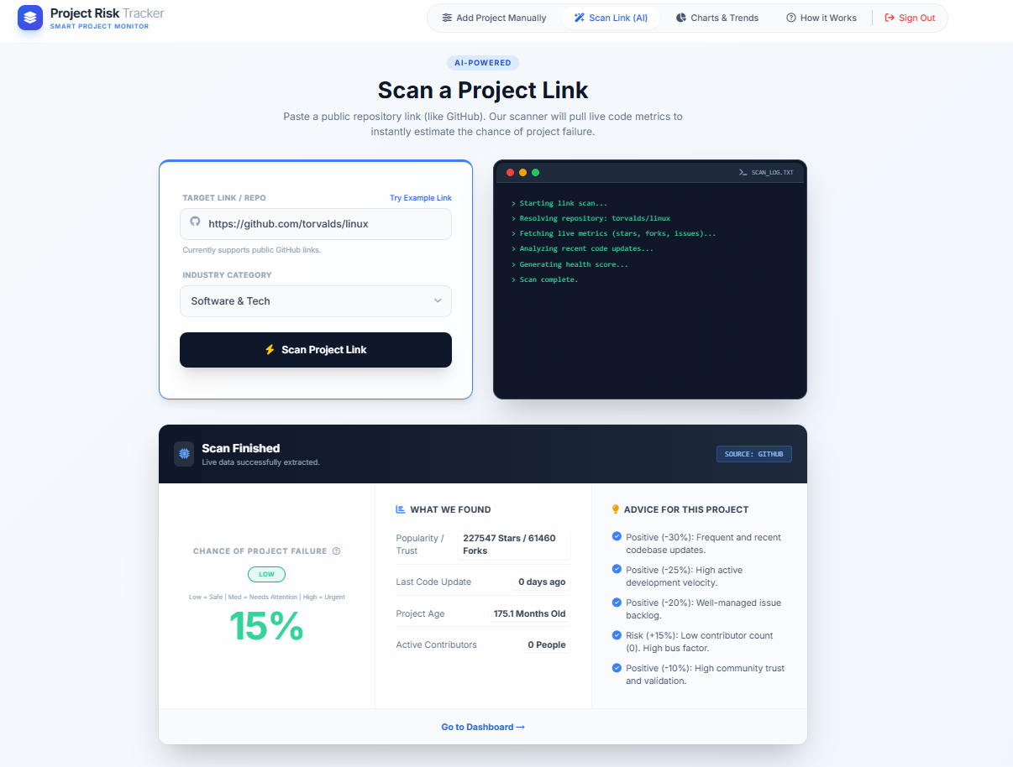

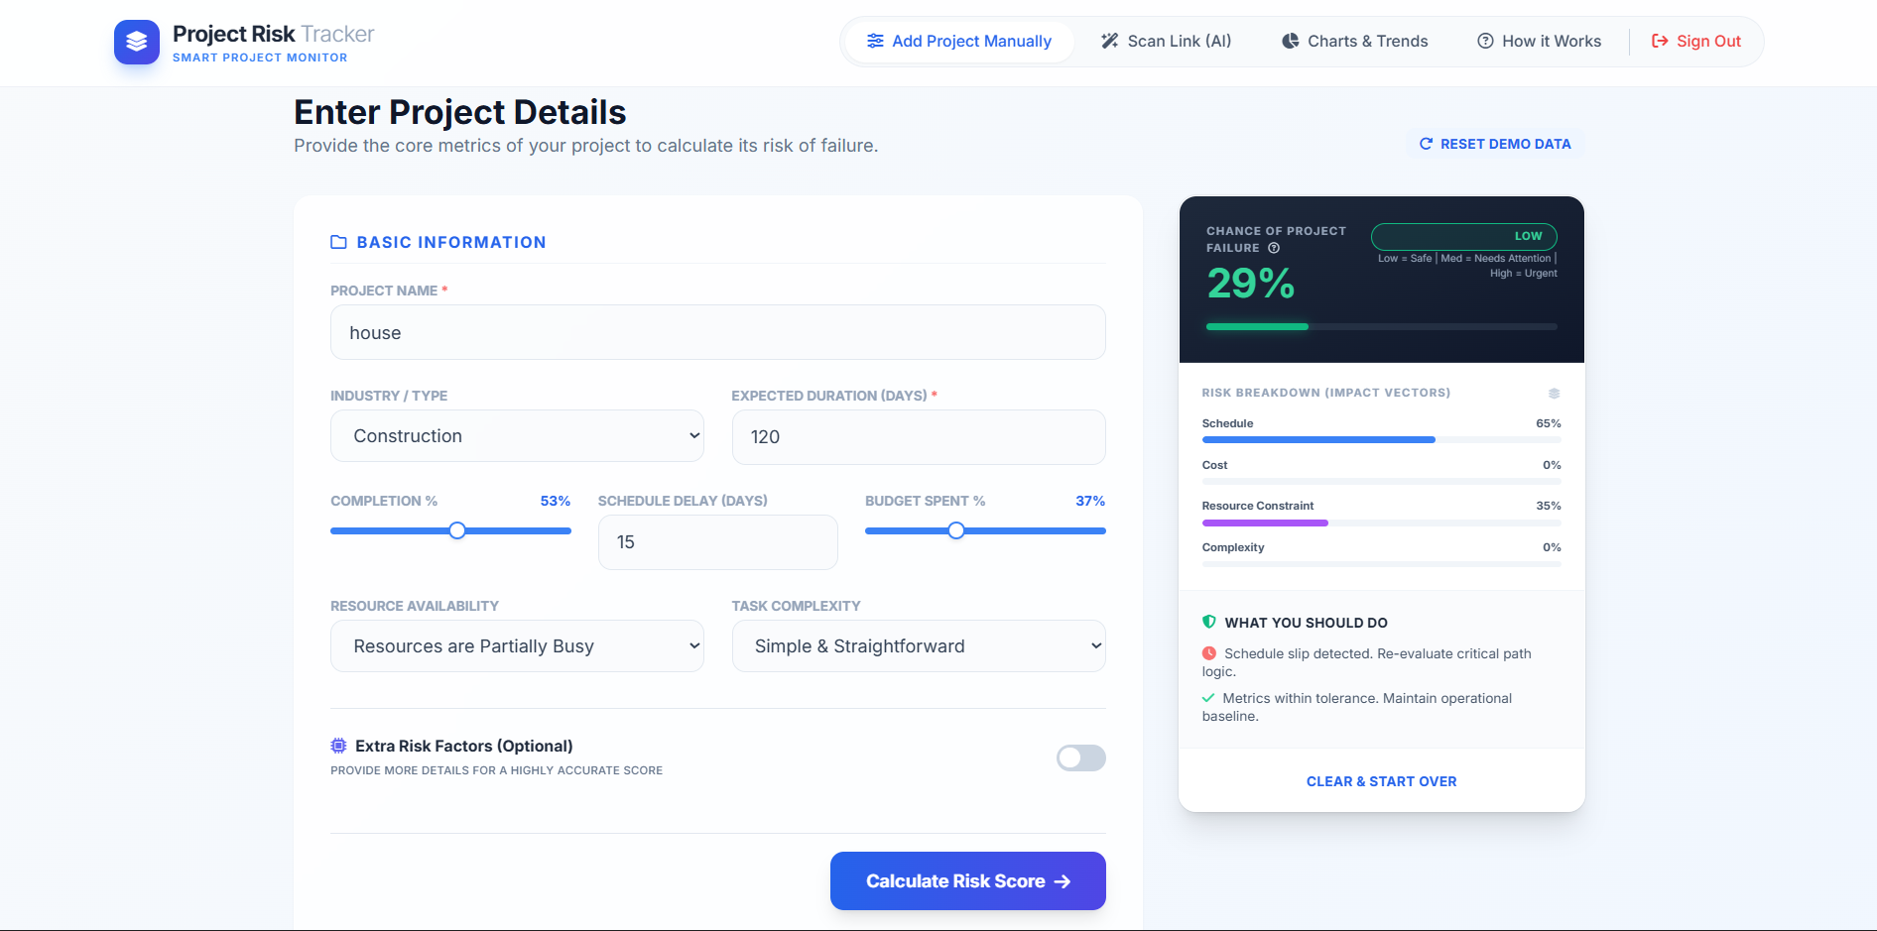

CHAPTER 5: CONCLUSION AND FUTURE WORK

5.1 Summary of Findings:
The project shows that real-time data analysis and structured scoring can effectively predict project risks and improve decision-making.

5.2 Conclusions Drawn:
The system is scalable, secure, and efficient. It successfully integrates full-stack development with data-driven risk prediction.
5.3 Recommendations and Future Scope:
- Implement machine learning models
- Improve prediction accuracy
- Add support for more tools
- Enhance UI/UX
- Deploy on cloud for scalability
Table 1.1:
Stage | User Action | System Response | Output
1 | User Signup/Login | Authenticate using JWT | User Dashboard
2 | Enter Project Details / GitHub URL | Fetch and analyze data | Project Data Loaded
3 | Risk Analysis | Apply scoring/ML model | Risk Score
4 | View Dashboard | Display charts & insights | Risk Visualization
5 | Save Project | Store in MongoDB | Saved Project Data
6 | View Recommendations | Generate AI insights | Action Suggestions

